

**<<Gamestore >>**

**Software Requirement Specification**

– Hochiminh, September 2022 –

**Table of Contents**

I. Overview 3

1. Introduction 3

2. System Functions 4

3. Common Requirements 5

II. Functional Requirements 6

1. <<Feature Name 1>> 6

a. <<Function Name 1>> 6

b. <<Function Name 2>> 6

2. <<Feature Name 2>> 6

# I. Overview

## 1. Introduction

Buying and selling game keys is now very popular in the gaming community. The website that sellsgames is created to help the gaming community stay up to date with the latest paid games at attractive promotional prices. At the same time, the website will contain the latest articles on many different game genres

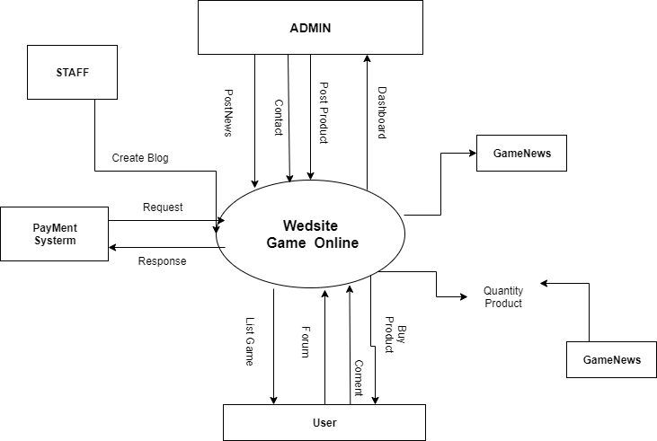>>

## 2. System Functions

#### a. Screen Flow

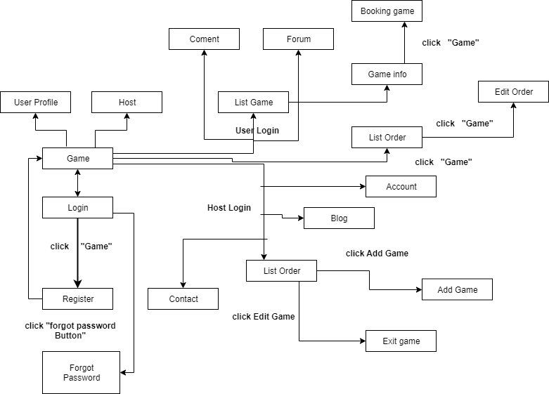

#### b. Screen Details

|  |  |  |  |
| --- | --- | --- | --- |
| **#** | **Feature** | **Screen** | **Description** |
| 1 | Display all lists of the app | User | Print all game and genre lists for users. |
| 2 | Login | Login | Sign in with your registered account. |
| 3 | Filter | User | Search by user-selected price, by rating and category. |
| 4 | Forgot password | Login | A new password will be generated and sent to the email registered by the user. |
| 5 | Checkout | User | Users check the order again, enter their full address and information. |
| 6 | Dashboard | Admin | Admin can see the number of paid orders, the number of visitors and the total revenue of the sales page. |
| 7 | Buy product | User | Users can add products and adjust the number of products they want to buy, the screen will print the total amount to pay. |
| 8 | Add new product | Admin | Admin will add, delete, edit prices and products. |
| 9 | Registration | User | Create an account with username, password and email. |
| 10 | Comment | User | Users can feel carefully about the game experience |
| 11 | Blog | Admin | Staff blogging for the page |
| 12 | Edit_Blog | Admin | Admin can delete posts |
| 13 | Creat_Blog | Staff | Staff create and edit articles |
| 14 | Create_Account | Admin | admin create account for staff |
| 15 | Checkout_user | User | Check your own purchase history |
| 16 | Checkout_admin | Admin | Admin check all orders of my shop |
| 17 | Comment_Admin | Admin | Read and delete Comment |
| 18 | Forum | User | Post |
| 19 | Show_Staff | Admin | List all staff |
| 20 | Edit_AccountStaff | Admin | Edit Account Staff |

#### c. User Authorization

|  |  |  |
| --- | --- | --- |
| **Screen** | **User** | **Admin** |
| Homepage | x | x |
| Login | x | x |
| List Shop | X | X |
| Create new product |  | x |
| Dashboard |  | x |
| Views Game News | x |  |
| Post Game News |  | x |
| Checkout | x |  |
| Buy product | x |  |
| Edit Profile | x | x |
| Checkout | x | x |
| FindJob | x |  |
| Applicant |  | x |
| Blog |  | x |
| Comment | x |  |
| Reply |  | x |
| CreateAccount |  | x |
| Checkout_user | x |  |
| Checkout_admin |  | x |
| Comment_Admin |  | x |
| Forum | x |  |
| Show and Edit_Staff |  | x |

In which:

* Role1: User
* Role2: Admin

#### d. Non-Screen Functions

|  |  |  |  |
| --- | --- | --- | --- |
| **#** | **Feature** | **System Function** | **Description** |
| 1 | Username | Registration | Non special characters. |
| 2 | Password | Registration | Need 6 characters. |
| 3 | Email | Registration | Correct format xxx@xxxx |
| 4 | Buy Product | Shopping Cart | Need Login |
| 5 | Filter | Shopping Cart | Search allow rating, genre, name |
| 6 | Remember | Login | Save cookies user |
| 7 | Search | Search | Users can search by Vietnamese and letters in the product name |
| 8 | Filter | Search | Adjust the price using the toolbar and search within |
| 9 | Password | Registration | Encode before insert database |
| 10 | Contact | User | User can conntact with admin |
| 11 | Dashboard | User | User can comment |
| 12 | Paypal | Pay | Pay via Paypal |
| 13 | Edit Profile | Pay | Users update information |
| 14 | Admin_Checkout | Page | Admin can check all paid orders |
| 15 | User_Checkout | User | User double check his order |
| 16 | Comment | User | Comment in each blog |
| 17 | Edit Comment | Admin | Admin can delete Comment if spam |
| 18 | Forum | User | User can post anything |
| 19 | Update Account Staff | Admin | Delete or update account staff |
| 20 | Blog | Staff | Staff blogging for the page |
| 21 | Comment_blog | User | Users comment on blog posts |
| 22 | Reply_Contact | Staff | Admin responds to contact messages |
| 23 | EditBlog | Admin,Staff | Add delete edit blog |
| 24 | CreateAccount | Admin | Create Accout Staff |
| 25 | Check_Account | Admin | Show account staff |

## 3. Common Requirements

*<<fill here with all the common requirements...>>*

# II. Functional Requirements

## 1. Gamepage

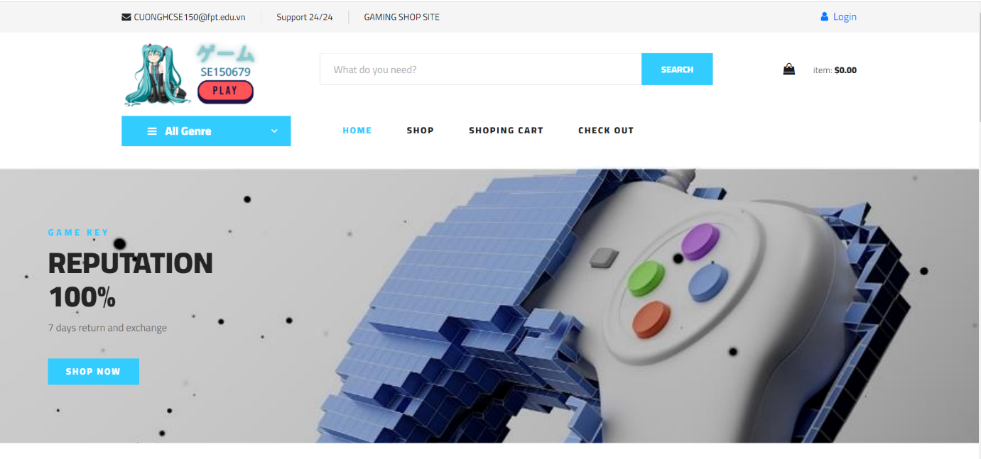

### 

### 2. Checkout

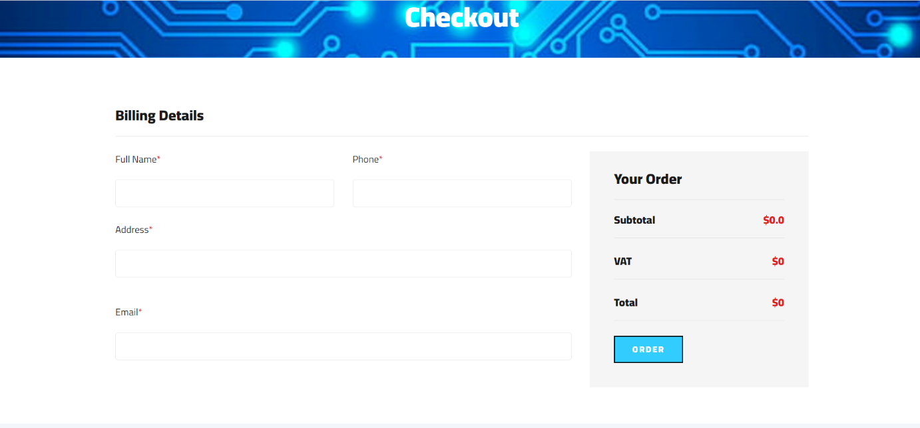

### 

3. View Shop

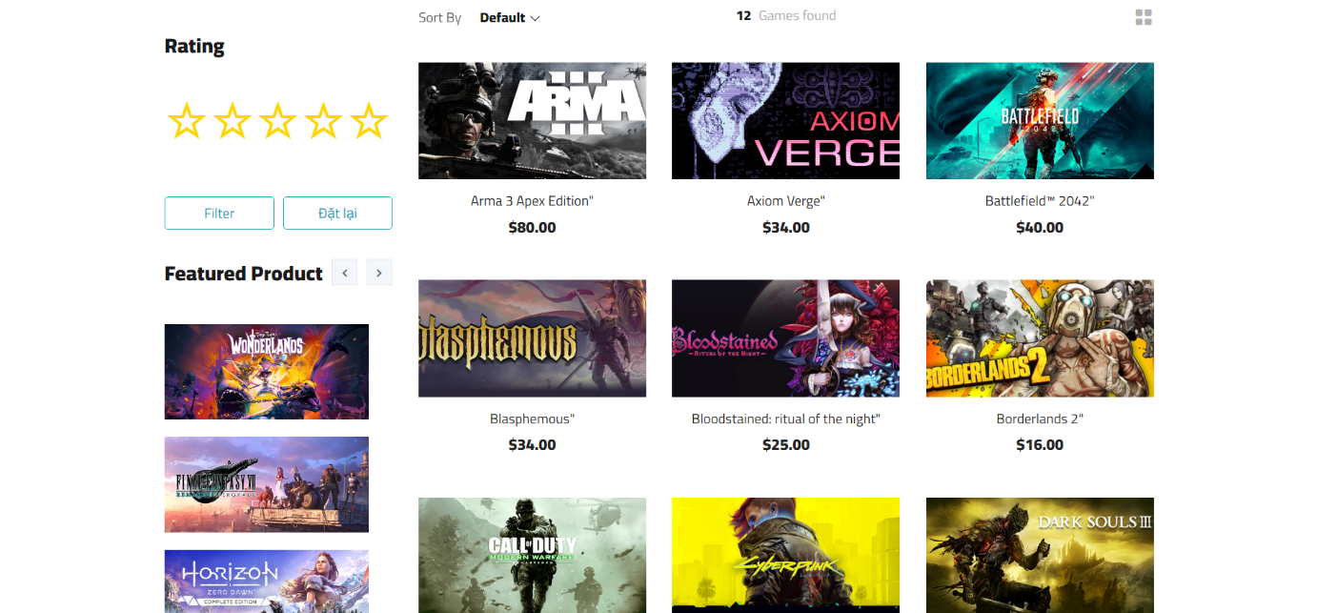

### 4. Filter in View Shop

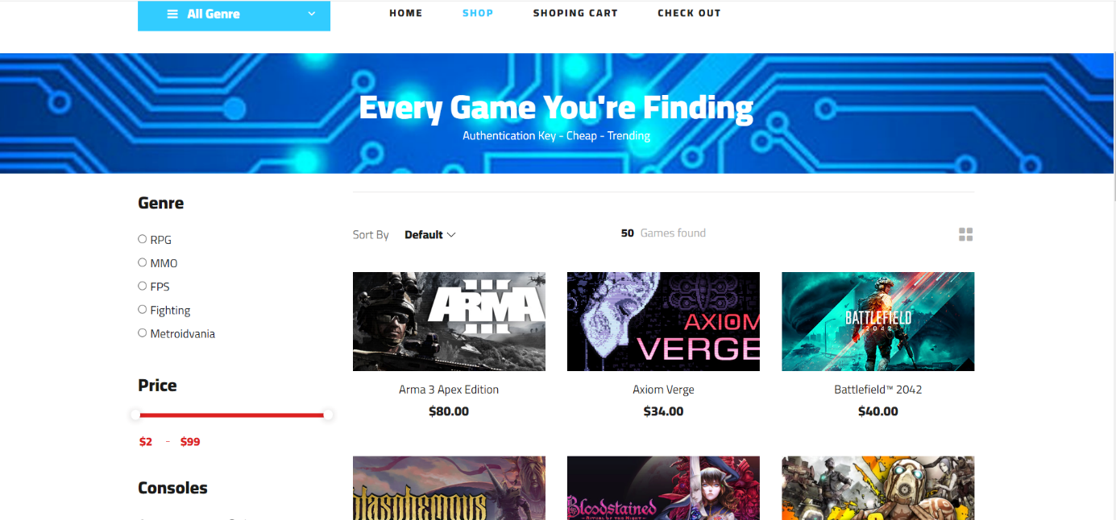

### 5. Shopping cart

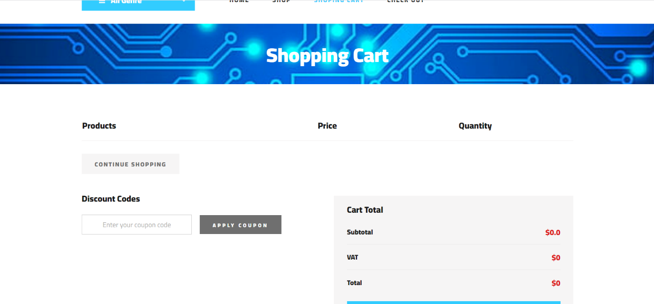



6.Forgot Password

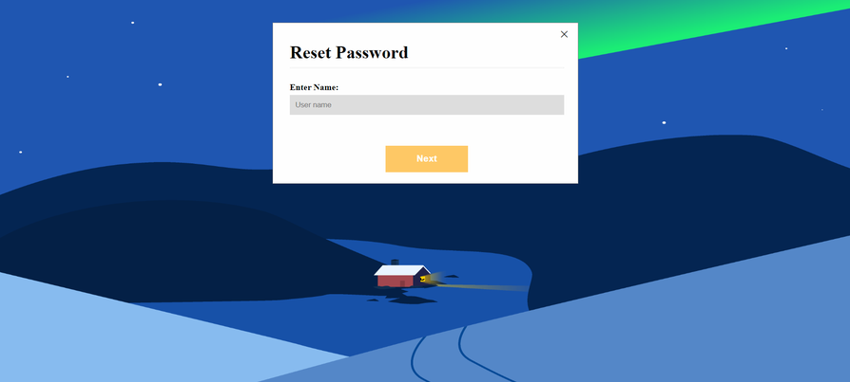

7.Login

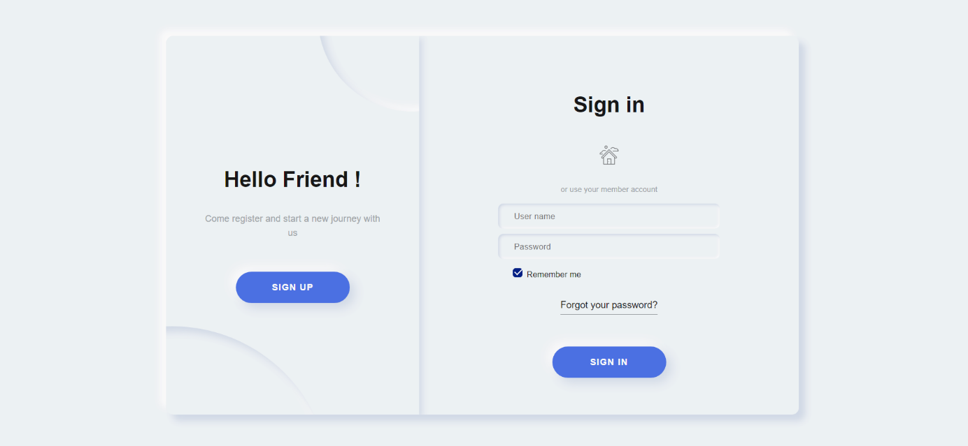

7.Blog

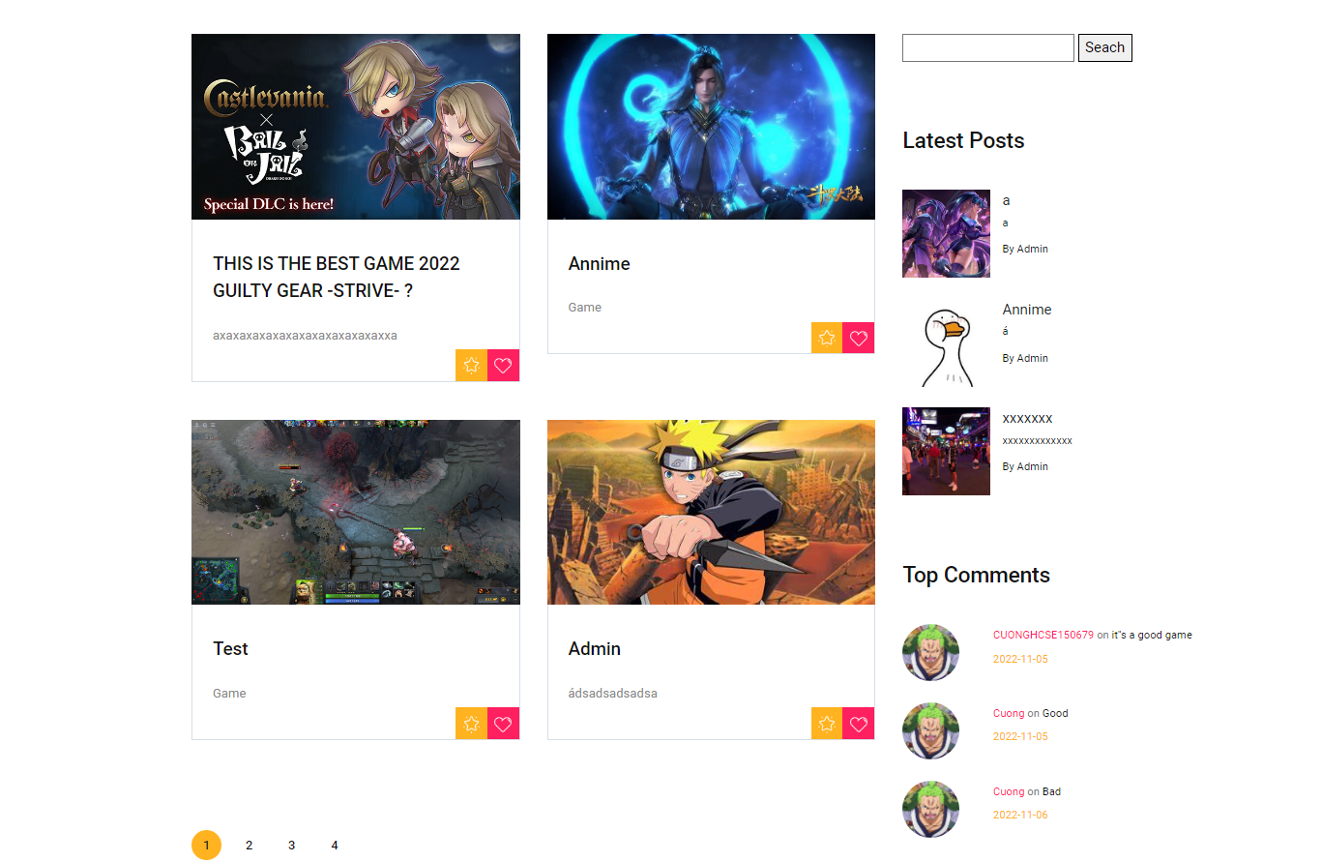

8.Forum

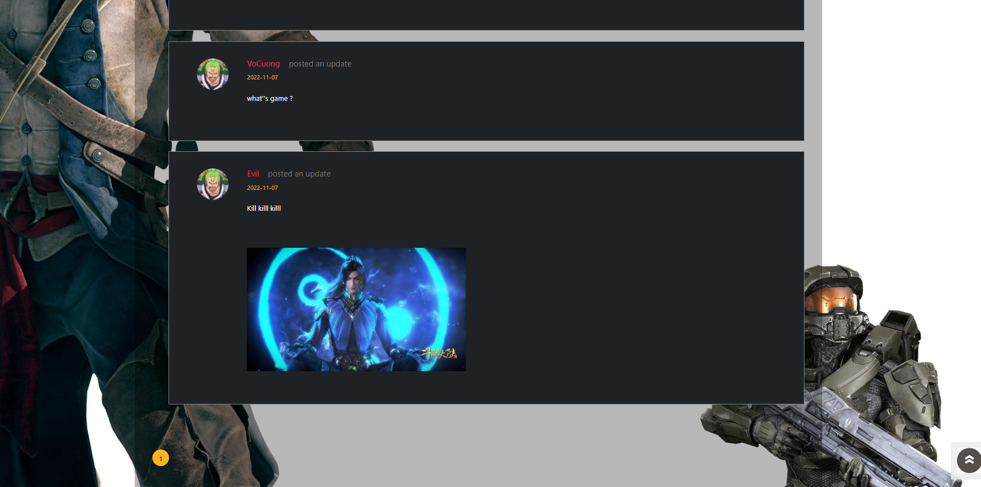

9.Create Blog

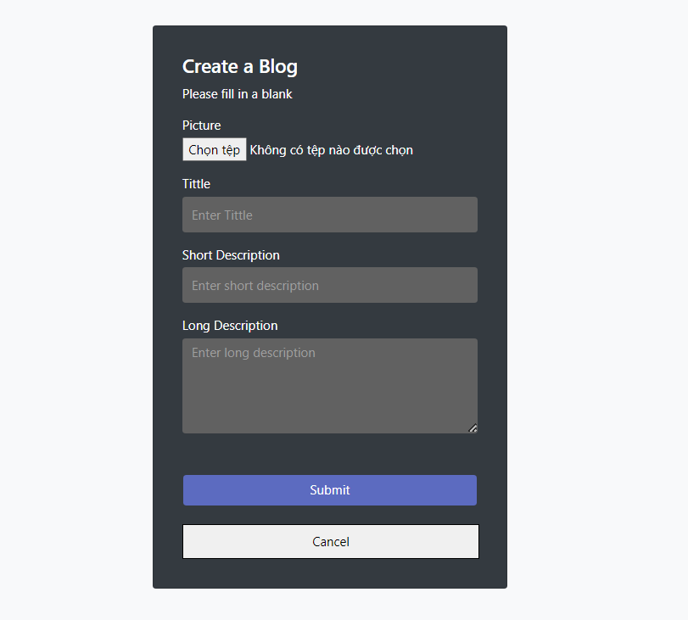

10.Checkout User

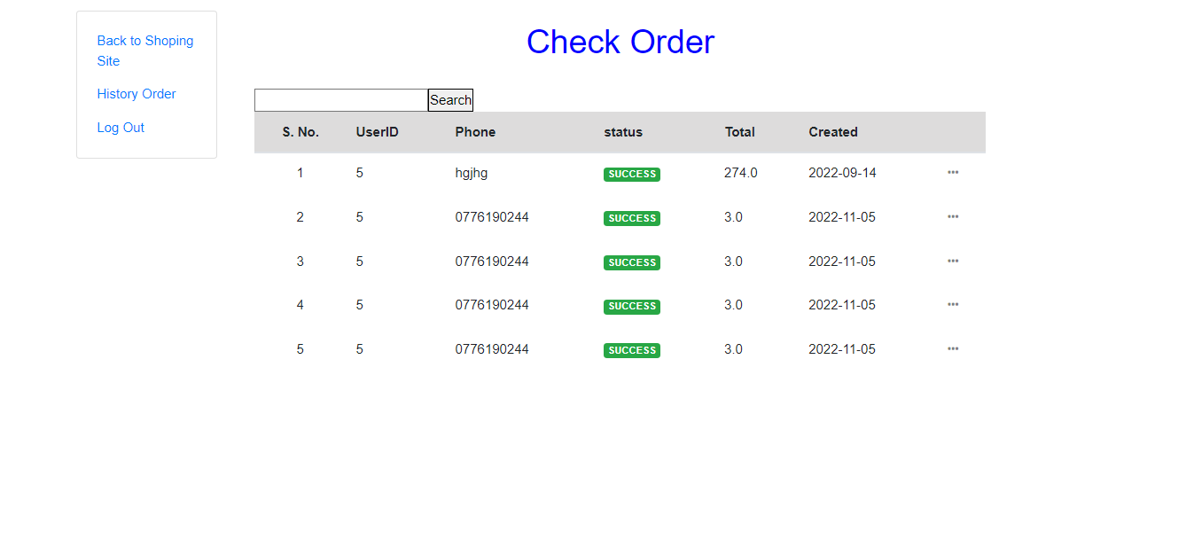

11.Detail Product

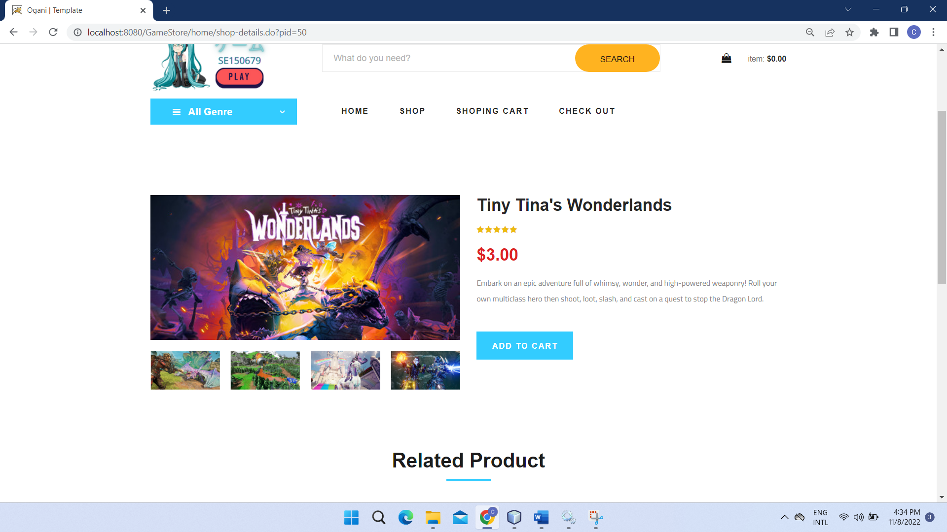

12.Management Admin

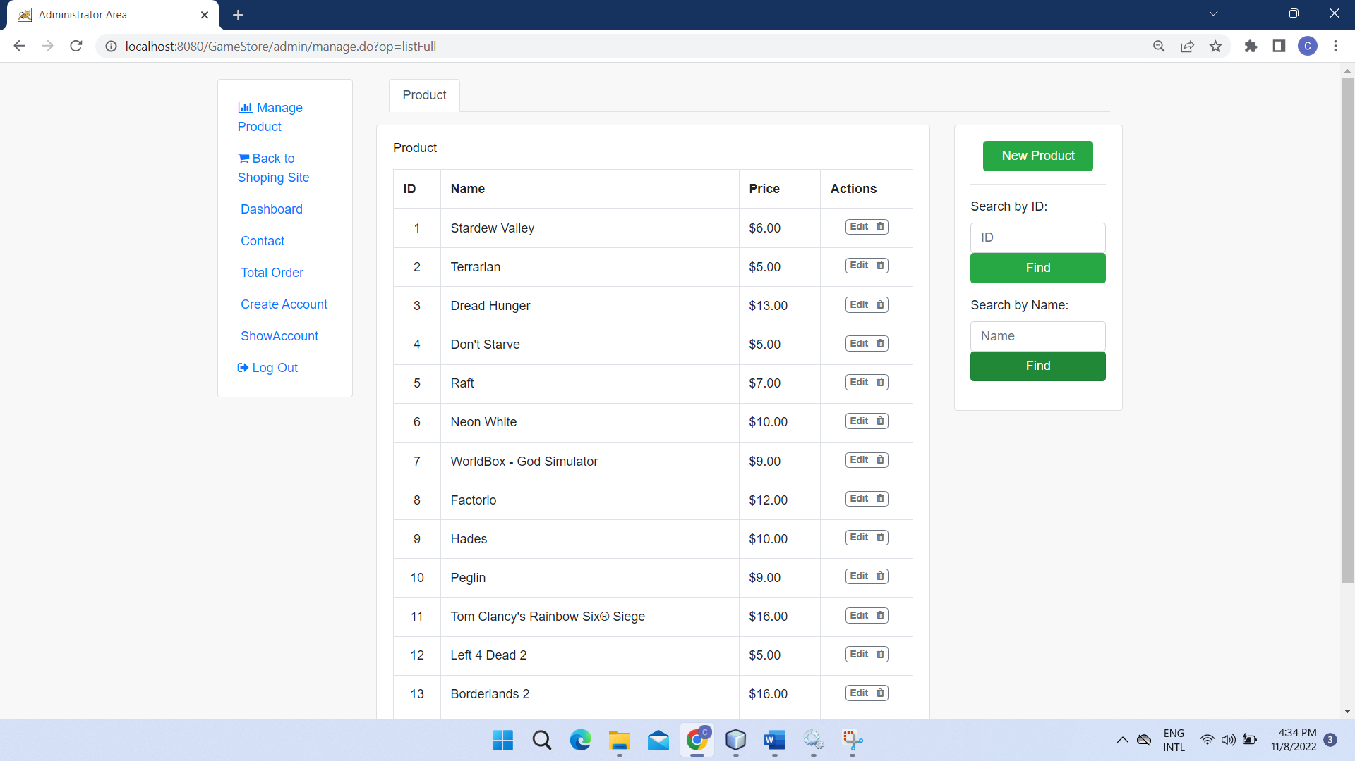

13. DashBoard

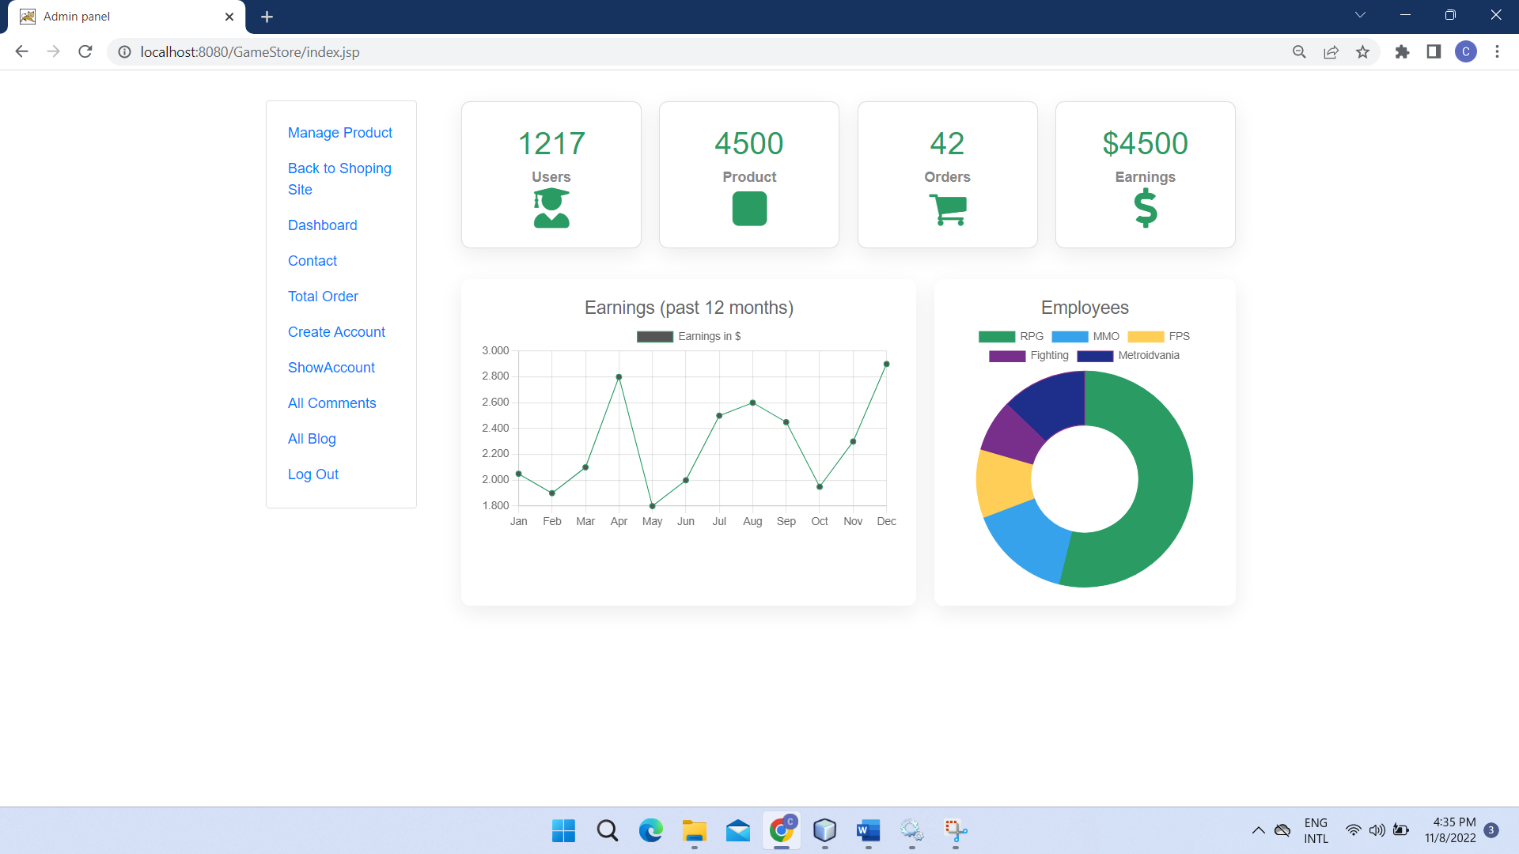

14.Contact

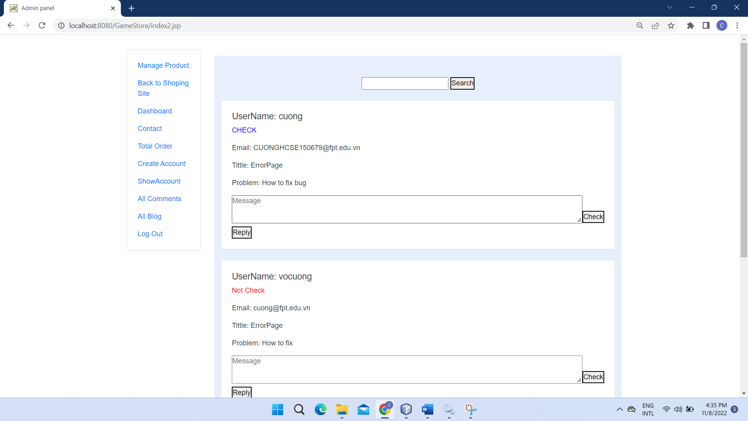

15.Admin Checkout

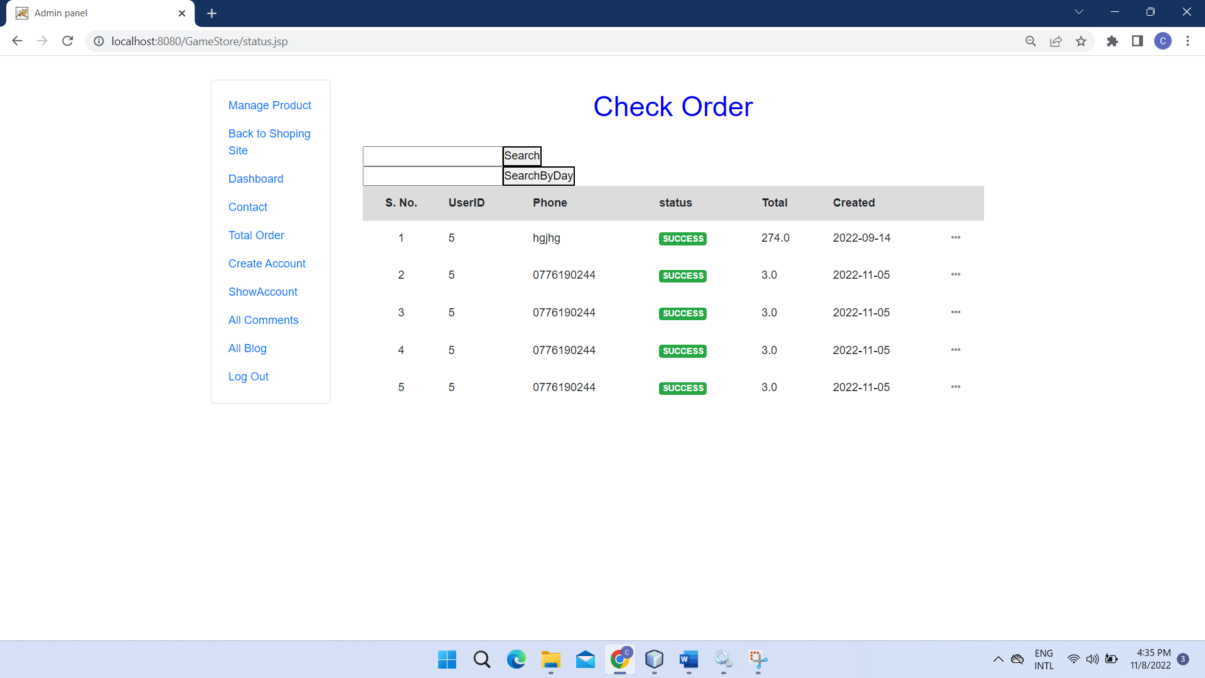

16.Create Staff

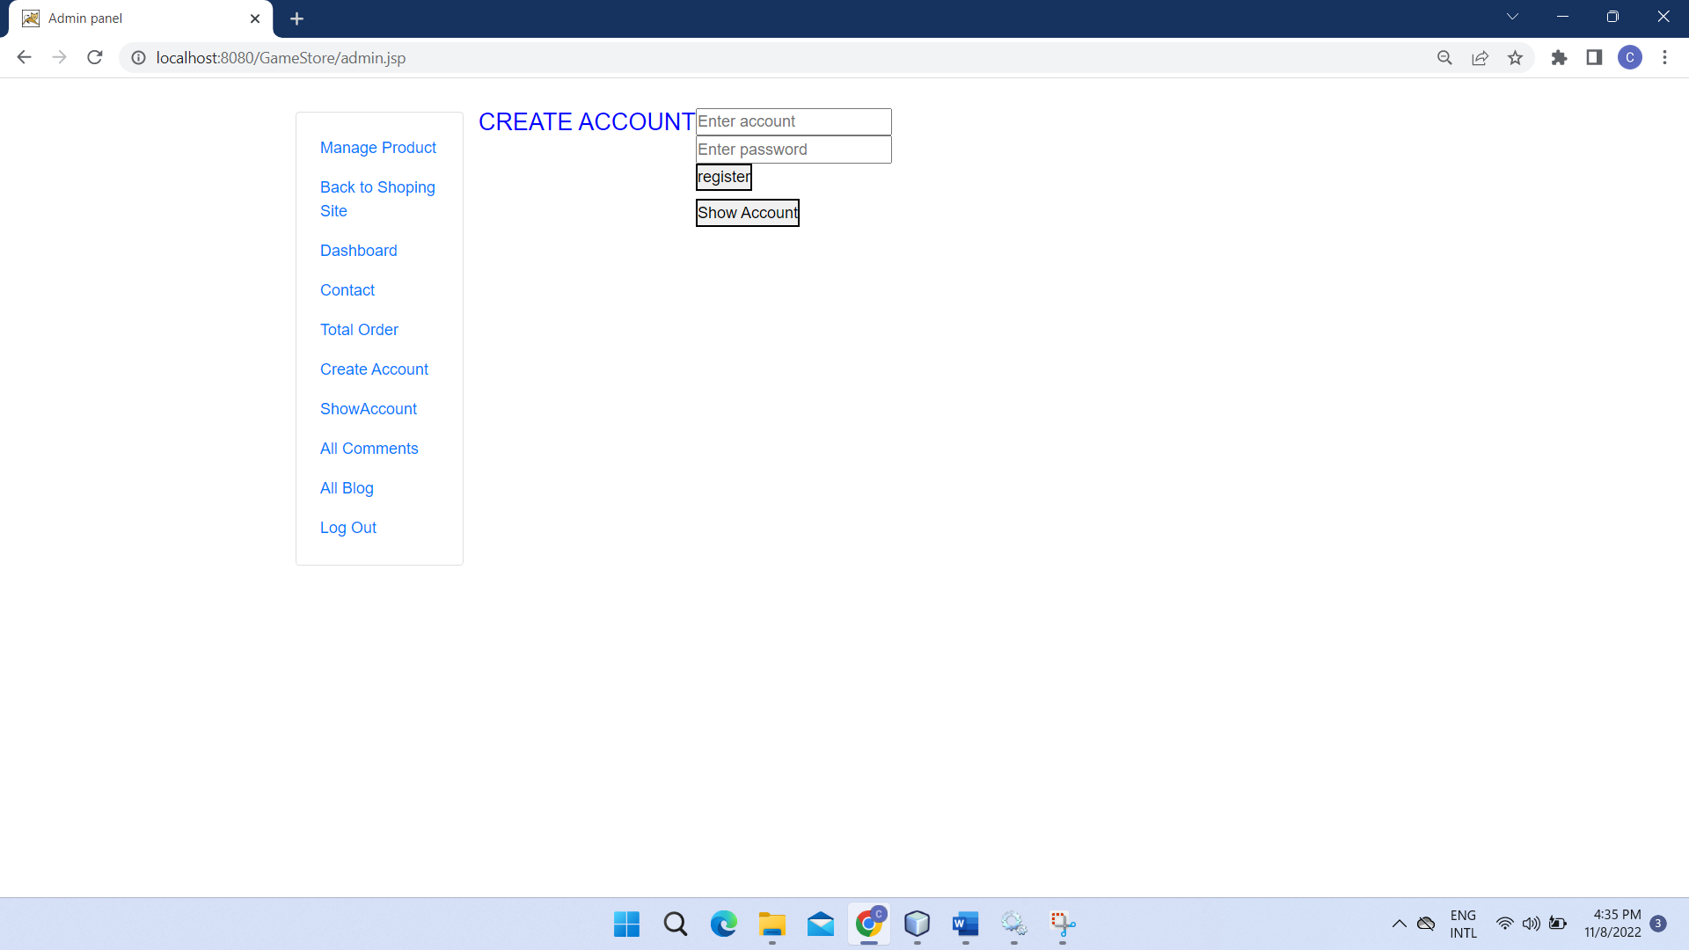

17.Show Staff



18.Show Blog Admin

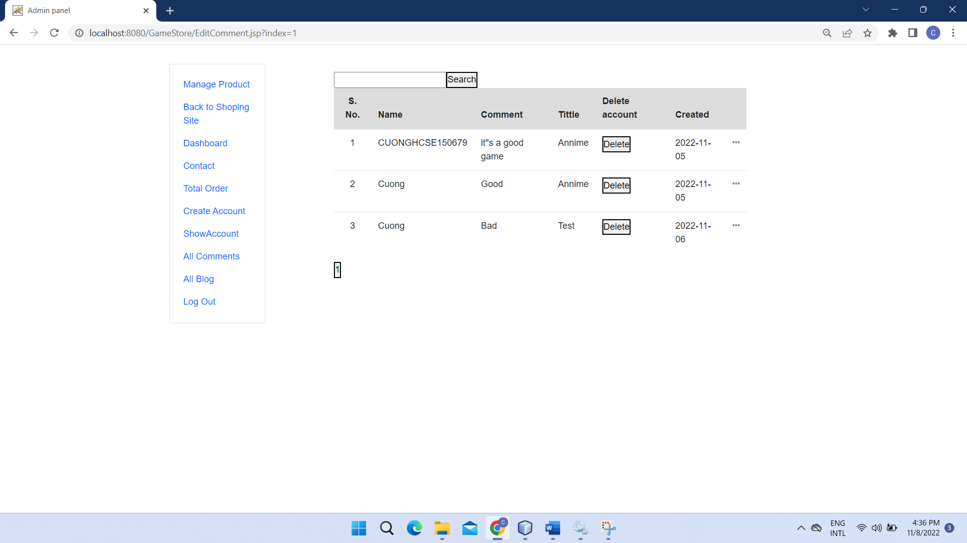

19.Show Comment Admin

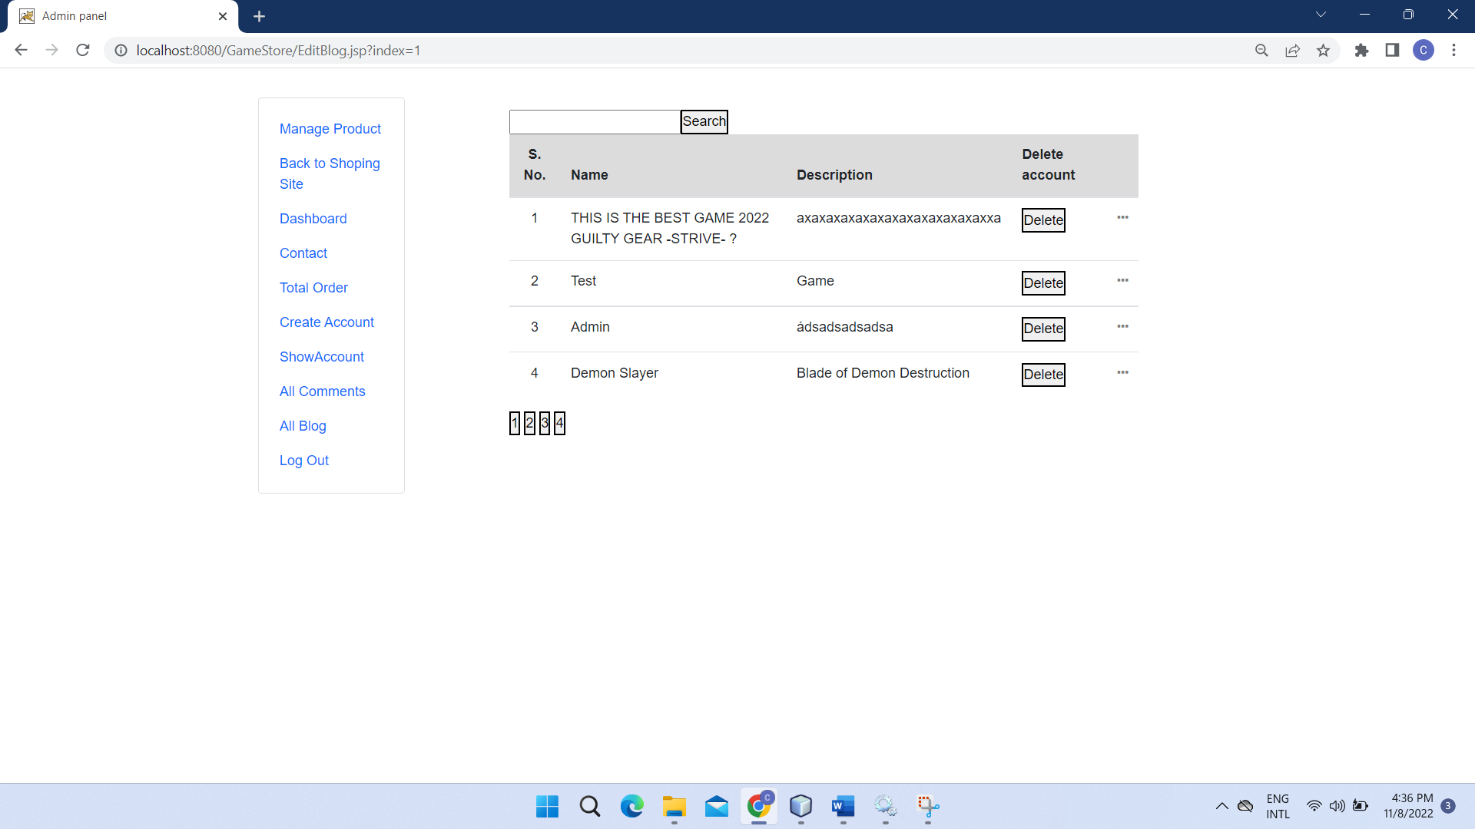

20.Edit Staff

